Table of Contents

MULTIPLE DISEASE PREDICTION 3
ACKNOWLEDGEMENT 4
ABSTRACT 5
1. INTRODUCTION 6
2. PROBLEM DEFINITION 7
2.1. Existing System 7
2.2. Proposed System 8
3. FEASIBILITY ANALYSIS 10
3.1. Technical Feasibility 10
3.2. Operational Feasibility 11
3.3. Economic Feasibility 11
4. SOFTWARE REQUIREMENT SPECIFICATIONS 11
4.1. System Requirements 11
4.1.1. Hardware Requirements 13
4.1.2. Software Requirements 15
5. SYSTEM DESIGN 16
5.1. Modules 17
5.1.1. Admin Login Module 17
5.1.2. Admin Dashboard Module 17
5.1.3. Patient Verification Module 17
5.1.4. Heart Disease Prediction Module 18
5.1.5. Diabetes Prediction Module 18
5.1.6. Liver Disease Prediction Module 19
5.1.7. Report Generation Module 19
5.2. UML Diagrams 20
5.2.1. Use Case Diagram 20
5.2.2. Class Diagram 20
5.2.3. Activity Diagram 21
5.2.4. State Diagram 22
6. IMPLEMENTATION 23
6.1. Data Preparation and Machine Learning Model Development 23
6.2. Backend Development 23
6.3. Database Setup 23
6.4. Frontend Development 24
6.5. Prediction Workflow Integration 24
6.6. Report Generation 24
7. TESTING 25
7.1. Testing Strategies 25
7.2. Test Cases 26
7.2.1. Unit Testing 26
7.2.2. Functional Testing 26
7.2.3. Integration Testing 27
7.2.4. System Testing 27
7.2.5. Acceptance Testing 28
8. CONCLUSION 28
8.1. FUTURE ENHANCEMENTS 28
9. BIBLIOGRAPHY 29
APPENDIX – UI 30

MULTIPLE DISEASE PREDICTION

EXPERT SYSTEM

ACKNOWLEDGEMENT

I would like to express my sincere gratitude to all those who supported me throughout the development and completion of this Multiple Disease Prediction Expert System project.
First, I would like to thank my project guide Dr. S. L. Jayalakshmi for her invaluable guidance and support throughout the project. Her continuous encouragement, insightful feedback, and expert advice were instrumental in the successful completion of this work.
I am also grateful to Pondicherry University for providing the resources and an ideal learning environment. The access to software tools, libraries, and academic resources greatly enhanced the quality of the project.
Special thanks to my family and friends for their unwavering support and encouragement throughout the project. Their patience and understanding kept me motivated, and I am deeply thankful for their belief in me.
I would also like to acknowledge the research papers, books, and online resources that I referred to during the development of the system. The information and knowledge gained from these resources helped me in making informed decisions and overcoming the challenges faced during the project.
Finally, I am thankful to the developers of the tools, libraries, and frameworks used, such as Python, PHP, Jupyter Notebook, and the machine learning libraries (NumPy, Pandas, Scikit-learn, etc.), which made it possible to build an efficient and accurate disease prediction system.
Thank you to everyone who contributed directly or indirectly to this project. Your support has made this project a reality.

Eesam Thanu Bishwanth Baji

ABSTRACT

This project focuses on developing a multiple disease prediction system capable of forecasting the likelihood of heart disease, diabetes, and liver disease using two distinct machine learning models: Random Forest Regressor, Linear Regression. The system leverages publicly available datasets to train and validate each model, ensuring accuracy and reliability. The datasets undergo preprocessing, including normalization, feature selection, and handling missing values, to enhance the predictive performance of the models. Each model is then evaluated using metrics such as accuracy score to compare their effectiveness in predicting the diseases. A user-friendly interface is developed using a web framework, allowing users to input relevant medical data and receive predictions regarding their risk of developing heart disease, diabetes, or liver disease. The final system aims to assist healthcare professionals and patients in making informed decisions by providing an early warning system for these conditions.

Chapter 1

INTRODUCTION

The rapid advancements in healthcare and machine learning have led to the development of predictive systems aimed at diagnosing diseases early and accurately. However, most existing systems are designed to focus on a single disease, such as heart disease, diabetes, or liver conditions. This limitation forces healthcare professionals and users to rely on multiple systems, increasing operational costs, time, and complexity. Additionally, many models suffer from reduced accuracy due to insufficient parameters, which can significantly affect patient health outcomes.
This project addresses these challenges by developing a unified Multiple Disease Prediction Expert System capable of predicting multiple diseases, including heart disease, diabetes, and liver disease, using machine learning techniques. By consolidating predictions into a single system, it eliminates the need for separate models, thus reducing time and resource consumption.
The system leverages Logistic Regression for heart disease and diabetes predictions, providing efficiency and reliability in binary classification. For liver disease prediction, the Random Forest algorithm is used, offering robustness and high accuracy in handling complex datasets. The models were developed in Python using powerful libraries such as NumPy, Pandas, and Matplotlib for data preprocessing, analysis, and visualization.
To enhance usability, the project includes a web application with a simple and intuitive interface. The frontend, built with HTML, allows users to input patient details and test parameters, while the backend, implemented in PHP, integrates Python models to provide real-time predictions. This integrated approach ensures accurate and efficient disease predictions while making the system accessible to a broader audience.
This work aims to improve healthcare decision-making by offering a cost-effective, accurate, and unified solution for the prediction of multiple diseases, contributing to better health outcomes and streamlined processes.

Chapter 2

PROBLEM DEFINITION

Many existing machine learning models for health analysis focus on a single disease per analysis. For instance, one model is used for liver analysis, another for cancer analysis, and yet another for lung condition analysis. If users want to predict multiple diseases, they often need to search across different systems, as there is no unified platform.
This analysis aims to provide predictions for multiple diseases within a single system. However, this is challenging because some models are less accurate, which can severely impact a patient’s health. For organizations analyzing patient health reports, relying on multiple models increases both cost and time.
While some existing systems are flexible, they often use fewer parameters, which can lead to inaccurate results.

EXISTING SYSTEM

In the current landscape, disease prediction systems are typically designed to handle only one specific disease at a time. These systems are often built with machine learning or statistical models trained on datasets focused solely on a single condition, such as heart disease, diabetes, or liver disease. While effective for their intended purpose, these systems present several limitations when users or healthcare providers need to predict multiple diseases simultaneously.
Key Characteristics of Existing Systems:
- Single-Disease Focus
  - Systems are specialized for one disease, such as:
    - Heart disease prediction models using logistic regression or neural networks.
    - Diabetes analysis based on glucose levels or body metrics.
    - Liver disease prediction using decision trees or ensemble methods.
  - Users must access separate systems for each condition, creating inefficiency.
- Cost and Resource Intensive
  - Developing and maintaining multiple disease-specific models increases costs for healthcare organizations.
  - Using separate platforms or tools for each disease consumes time and effort.
- Accuracy Issues
  - Many existing systems rely on fewer parameters or limited datasets, leading to less accurate predictions.
  - Insufficient generalization can result in misdiagnoses, negatively impacting patient outcomes.
- Lack of Integration
  - Current systems are not designed to work together or share data, resulting in isolated predictions.
  - This lack of a unified platform complicates healthcare workflows and increases the risk of errors.
- Limited Accessibility
  - Some systems require advanced technical expertise to operate, making them less user-friendly.
  - General users or non-technical healthcare workers may find it difficult to use these systems effectively.
Limitations of Existing Systems:
- Fragmentation: Separate tools for different diseases are inefficient for multi-disease analysis.
- Time Consumption: Users must input and analyze data multiple times across various platforms.
- High Costs: Licensing and maintaining multiple systems increase financial burdens.
- Variable Accuracy: Over-reliance on single-disease models and limited parameters can lead to inaccuracies.

PROPOSED SYSTEM

The Multiple Disease Prediction Expert System is designed to address the limitations of existing single-disease prediction systems by offering a unified platform capable of predicting multiple diseases, such as heart disease, diabetes, and liver disease, within a single interface. This system leverages advanced machine learning algorithms for accurate predictions while ensuring accessibility and efficiency through an intuitive web-based application.

Key Features of the Proposed System:
- Unified Platform
  - Combines predictive models for heart disease, diabetes, and liver disease, eliminating the need for multiple systems.
  - Reduces time and effort by allowing users to analyze various diseases simultaneously.
- Machine Learning Models
  - Logistic Regression: Used for heart disease and diabetes prediction, known for its reliability in binary classification problems.
  - Random Forest: Applied for liver disease prediction, offering robustness and high accuracy for complex datasets.
  - These models are trained and validated on relevant datasets to ensure precise and reliable predictions.
- Web Application
  - A user-friendly interface built with HTML for the frontend and PHP for the backend.
  - Integrates Python-based machine learning models for real-time disease predictions.
  - Users can input test parameters and receive predictions quickly, with options to view and download reports.
- Cost-Effectiveness
  - Reduces operational costs by consolidating multiple disease prediction models into a single system.
  - Efficiently utilizes computational resources, ensuring scalability.
- Enhanced Accuracy
  - Uses comprehensive datasets and well-tuned machine learning models to improve prediction accuracy.
  - Incorporates multiple parameters for each disease, ensuring detailed analysis.
- Accessibility
  - Designed to be accessible to healthcare professionals and patients through a web-based interface.
  - Easy to use, requiring no advanced technical expertise to operate.

Advantages of the Proposed System:
- Time Efficiency: Streamlines the process of predicting multiple diseases, saving time for users.
- Improved Accuracy: Combines robust machine learning techniques to ensure reliable outcomes.
- Integrated Platform: Provides a centralized solution for multi-disease analysis.
- Cost Reduction: Minimizes the need for multiple platforms, reducing overall costs.
- Scalability: Can be extended to include additional diseases in the future.

Workflow of the Proposed System:
- User Interaction: Users input test parameters (e.g., patient data, test values) through the web interface.
- Model Selection: Based on the disease type, the system selects the appropriate model (Logistic Regression or Random Forest).
- Prediction: The system processes the input through the selected model to generate predictions.
- Result Generation: Predictions are displayed to the user, along with detailed reports available for download.

CHAPTER 3

FEASIBILITY ANALYSIS

TECHNICAL FEASIBILITY

This system leverages widely available technologies and programming tools, making it highly technically feasible.
- Platform: The system uses Python for model development and a combination of HTML and PHP for the web application, which are reliable and widely supported.
- Machine Learning Libraries: Libraries like NumPy, Pandas, and Matplotlib are efficient for scientific computing and data processing. Additionally, machine learning algorithms such as Logistic Regression and Random Forest are well-established and effective.
- Development Tools: The use of Jupyter Notebook for model creation ensures that the system is easy to develop, test, and maintain.
- Integration: Python's compatibility with PHP via backend scripts ensures seamless integration of the predictive models with the web application.

OPERATIONAL FEASIBILITY

The system is user-friendly and designed to meet the needs of healthcare professionals and patients:
- Ease of Use: The web interface ensures accessibility for both technical and non-technical users.
- Workflow Efficiency: A unified system reduces the time spent switching between multiple platforms, improving operational efficiency.
- Training Requirements: Minimal training is required to operate the system, as the interface is intuitive.

ECONOMIC FEASIBILITY

The proposed system minimizes costs while maximizing utility:
- Development Costs: Open-source tools and libraries, such as Python, NumPy, and Matplotlib, are free to use.
- Hardware Requirements: The system can run on standard computing hardware, requiring no specialized equipment.
- Maintenance Costs: The unified platform reduces the need for multiple systems, leading to cost savings on maintenance and updates.
- Cost to Users: Healthcare organizations can save significant resources by avoiding the need for separate disease-specific models.

CHAPTER 4

SOFTWARE REQUIREMENT SPECIFICATIONS

SYSTEM REQUIREMENTS

The system integrates a Python-based backend for prediction models with a web-based interface built using HTML and PHP. Users input patient data, which is processed by machine learning models to predict the likelihood of heart disease, diabetes, or liver disease. The results are displayed and can be downloaded as a report.
Functional Requirements
Admin Features
- Login and authentication.
- Select the disease for prediction.
- Enter patient ID and test parameter values.
- Generate and download the patient health report.
Prediction System
- Process patient input through the appropriate machine learning model:
  - Logistic Regression for heart disease and diabetes.
  - Random Forest for liver disease.
- Provide real-time predictions.
Web Application
- User-friendly interface for data input and result display.
- Generate downloadable reports.

Non-Functional Requirements
Performance
- The system must respond to user queries within 5 seconds.
Reliability
- Ensure predictions are accurate and models are trained on high-quality datasets.
Usability
- The interface should be intuitive, requiring minimal training for healthcare professionals.
Scalability
- The system should allow integration of additional diseases in the future.
System Architecture
- Frontend: Built with HTML to create a simple, interactive user interface.
- Backend: PHP scripts to connect the web application with Python-based machine learning models.
- Database: A database (e.g., MySQL) for storing patient records and test data.
- Machine Learning Models:
  - Logistic Regression for heart disease and diabetes.
  - Random Forest for liver disease.
Constraints
- Requires a stable internet connection for web application functionality.
- Predictions depend on the quality of input data.

Assumptions
- Users are familiar with basic medical terminology and test parameters.
- The system will primarily be used by healthcare professionals or trained staff.

Hardware Requirements
Client-Side (User/Admin Machine)
The hardware required for end-users (admins or users) to access the system via the web application:
- Processor:
Minimum Intel Core i3 or equivalent (dual-core, 2.0 GHz or higher).
Recommended: Intel Core i5 or equivalent for better performance.
- RAM:
Minimum 4 GB.
Recommended: 8 GB to handle browser-based operations smoothly.
- Storage:
At least 2 GB of free space for browser caching and temporary files.
- Display:
Screen resolution of 1366 x 768 or higher.
Recommended: Full HD 1920 x 1080 for a better user experience.
- Network Requirements:
Internet connection with a speed of 1 Mbps or higher.
Recommended: 5 Mbps or higher for faster response times.
- Operating System:
  - Windows 10 or newer.
  - macOS Mojave (10.14) or newer.
  - Linux-based distributions (Ubuntu 20.04 or higher).
- Browser Compatibility:
Latest versions of Chrome, Firefox, Edge, or Safari.

Server-Side (Hosting the Application and ML Models)
The hardware required for the server to handle data processing, predictions, and report generation:
- Processor:
Minimum Quad-Core CPU, such as Intel Xeon E3 or equivalent.
Recommended: Octa-Core Processor, such as Intel Xeon E5 or equivalent.
- RAM:
Minimum 16 GB to handle concurrent requests and ML model execution.
Recommended: 32 GB for better scalability and performance.
- Storage:
  - SSD Storage: Minimum 100 GB (scalable for storing patient data and reports).
  - Recommended: 500 GB SSD for faster read/write speeds.
  - Ensure additional backup storage for database and application data.
- Network Requirements:
Minimum 10 Mbps bandwidth for handling multiple simultaneous requests.
Recommended: 100 Mbps for optimal server performance in high-traffic scenarios.
- GPU (Optional for Faster ML Processing):
  - Minimum: NVIDIA GTX 1050 Ti (for smaller datasets).
  - Recommended: NVIDIA RTX 2060 or Tesla T4 (for larger datasets and faster predictions).
- Operating System:
  - Linux-based OS such as Ubuntu 20.04 LTS (preferred for better performance and compatibility).
  - Windows Server 2019 or newer (optional).
- Database Server:
Dedicated server or cloud-based hosting for MySQL/PostgreSQL database.
Recommended: Amazon RDS or Google Cloud SQL for scalability.

Optional Cloud Hosting (Instead of Physical Server)
- Cloud Service Provider:
  - AWS (Amazon Web Services): EC2 Instances (T2 or T3 medium instances for basic use, T3 large for higher performance).
  - Google Cloud: Compute Engine VM instances.
  - Microsoft Azure: Standard B2s or DS2v2 instances.
- Specifications for Cloud Server:
  - CPU: 4 vCPUs or higher.
  - RAM: 16 GB or higher.
  - Storage: 100 GB SSD.
  - GPU: Add-on (for ML acceleration).

Software Requirements
- Operating system: Windows 7 or above
- Front end: HTML, CSS, JS
- Design tool: Visual Studio Code, Jupyter notebook.
- Supported browsers: Chrome, Firefox, Edge, Brave .
- Frontend:
- HTML/CSS: For form creation and layout design.
- JavaScript: For client-side validation and dynamic updates.
- FPDF: For generating downloadable PDF reports.
- Backend:
- PHP: Handles form submission, prediction logic integration, and PDF generation.
- Python: For machine learning model inference using .sav files.
- Database:
- MySQL: Stores patient information for verification and retrieval.

SYSTEM DESIGN

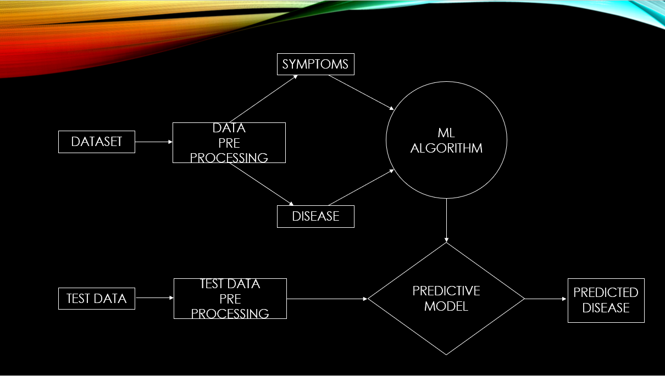
Figure 1 Machine Learning Model

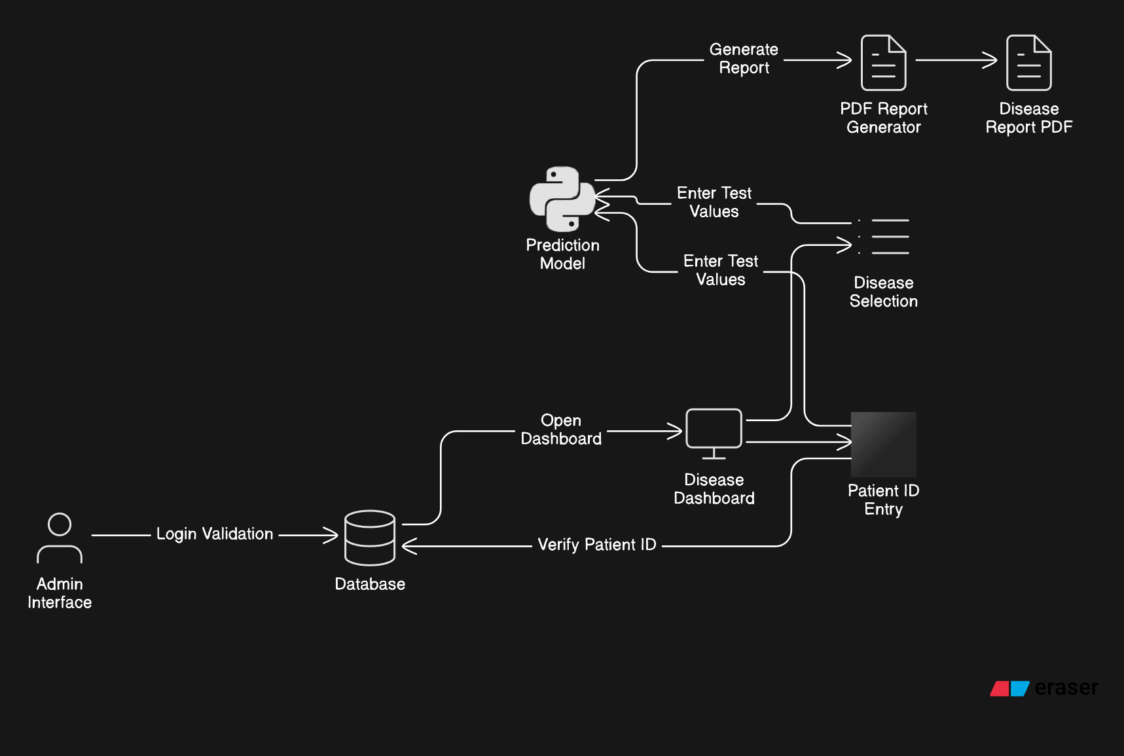
Figure 2 System Architecture

Modules

Admin Login Module
Purpose: The Admin Login Module is responsible for securely authenticating administrators before they can access the system.
Key Features:
- Admins enter a username and password.
- Input validation and error handling for invalid credentials.
- Uses hashed passwords for secure authentication.
- Implements session management to keep the admin logged in.
Workflow:
- Admin enters valid credentials.
- System verifies credentials against the database.
- If valid, the admin is redirected to the dashboard.
- If invalid, an error message is shown.

Admin Dashboard Module
Purpose: The Admin Dashboard is the central hub from which administrators manage the system, view patient records, and generate predictions.
Key Features:
- Displays an overview of the system.
- Allows the admin to view patient records and prediction results.
- Provides access to various system modules like patient data entry, prediction, and report generation.
Workflow:
- Admin logs in to the system and is redirected to the dashboard.
- Admin can view and manage patient data, predictions, and generated reports.
- Provides quick links to various functionalities like entering patient information and running predictions.

Patient Verification Module
Purpose: The Patient Verification Module ensures that only valid patients are included in the prediction process.
Key Features:
- Verifies patient details based on a unique patient ID.
- Validates the correctness of input fields such as name, age, and medical history.
- Ensures that all required patient information is entered before processing predictions.
Workflow:
- Admin enters a unique patient ID.
- The system checks the patient’s details in the database.
- If valid, the admin can proceed with predictions; if not, the system prompts for corrections.

Heart Disease Prediction Module
Purpose: The Heart Disease Prediction Module predicts the likelihood of a patient having heart disease using the logistic regression model.
Key Features:
- Accepts medical test inputs (such as blood pressure, cholesterol levels, etc.).
- Uses a pre-trained Logistic Regression model to predict heart disease risk.
- Outputs the prediction result (e.g., "Disease Present" or "Disease Not Present").
Workflow:
- Admin inputs test data for a patient.
- The system uses the trained logistic regression model to process the data.
- A prediction is generated and displayed (Heart Disease Risk: Yes/No).

Diabetes Prediction Module
Purpose: The Diabetes Prediction Module predicts whether a patient is likely to have diabetes based on medical test results.
Key Features:
- Accepts test values such as blood sugar, BMI, age, etc.
- Uses the logistic regression model trained on diabetes data for prediction.
- Provides a prediction on the likelihood of diabetes (e.g., "High Risk" or "Low Risk").
Workflow:
- Admin inputs relevant test values for the patient.
- The system processes the data using the diabetes prediction model.
- A result is returned indicating whether the patient is at risk of diabetes.

Liver Disease Prediction Module
Purpose: The Liver Disease Prediction Module assesses the likelihood of liver disease using Random Forest.
Key Features:
- Accepts medical test inputs (such as liver enzyme levels, bilirubin, etc.).
- Uses the Random Forest model to predict liver disease risk.
- Outputs a result indicating the probability of liver disease (e.g., "At Risk" or "No Risk").
Workflow:
- Admin enters test values for the liver disease prediction.
- The system uses the pre-trained Random Forest model to process the data.
- A prediction is displayed indicating whether the patient is at risk for liver disease.

Report Generation Module
Purpose: The Report Generation Module creates and stores detailed reports of prediction results, which can be accessed or downloaded by the admin.
Key Features:
- Generates a report in PDF format containing prediction results, patient information, and test data.
- Allows the admin to download or print the generated report.
- Stores reports in the system for future reference.
Workflow:
- After a prediction is made, the system formats the data into a professional PDF report.
- The report is saved in the database with a link for downloading.
- Admin can download or print the report from the dashboard.

UML Diagrams

Use Case Diagram
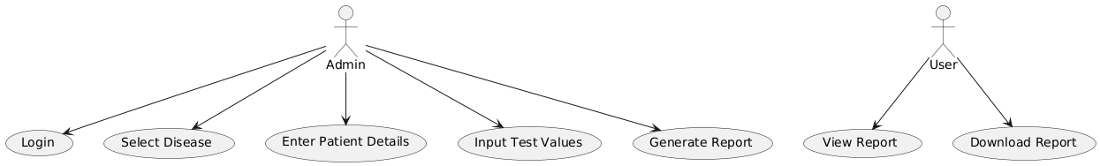
Figure 3 Use Case Diagram

Class Diagram
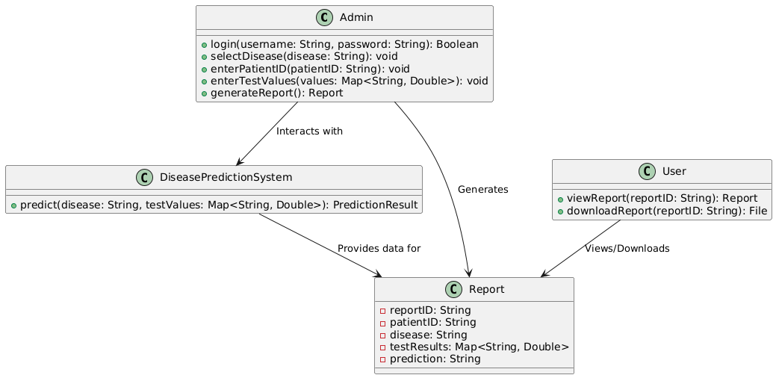
Figure 4 Class Diagram

Activity Diagram
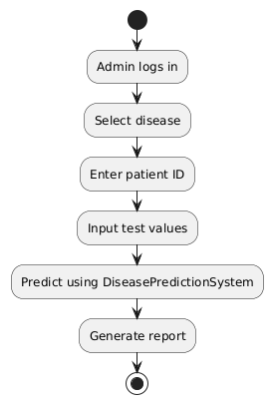
Figure 5 Activity Diagram

State Diagram
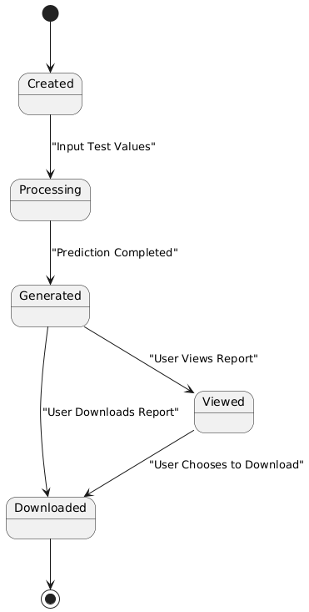
Figure 6 State Diagram

IMPLEMENTATION

Data Preparation and Machine Learning Model Development
- Collect datasets for Heart Disease, Diabetes, and Liver Disease from trusted sources (e.g., UCI repository, PIMA and Kaggle).
- Perform data preprocessing:
  - Handle missing values, normalize numerical features, and encode categorical variables.
- Develop and train machine learning models:
  - Use Logistic Regression for Heart Disease and Diabetes prediction.
  - Use Random Forest for Liver Disease prediction.
- Evaluate model performance using metrics like accuracy, precision, recall, and F1-score.
- Save the trained models as .pkl files using joblib for reuse in the production environment.

Backend Development
- Use PHP to create a web server that interacts with the prediction models via shell_exec.
- Develop a Python script to load the trained models and process predictions based on input data.
  - Use Flask/Django for testing predictions during development.
- In the PHP backend, create functions to:
  - Accept form input (patient data and selected disease).
  - Pass this input to the Python script using shell_exec.
  - Capture the script output (prediction result) and return it to the frontend.

Database Setup
- Create a MySQL database with tables for:
  - Users: Admin credentials for login.
  - Patients: Storing patient details and IDs.
  - Reports: Storing prediction results and generated reports.
- Design the schema to link patient data with prediction results and reports.
- Use PHP’s mysqli or PDO for database interaction:
  - To authenticate users.
  - To store/retrieve patient data and prediction outcomes.

Frontend Development
- Develop a login page for admin authentication.
  - Validate credentials against the MySQL database.
- Build a data input form for entering patient details and selecting diseases for prediction.
- Display prediction results dynamically after executing the backend logic.
- Create a section for downloading generated reports.

Prediction Workflow Integration
- After form submission, pass patient data and disease type to the PHP backend.
- Use PHP's shell_exec to call the Python prediction script:
  - Example: shell_exec("python predict.py --disease=heart --values=100,200,150").
- The Python script processes the input, predicts the disease outcome, and returns the result as a JSON string.
- The PHP script parses the JSON result and stores it in the database.

Report Generation
- Develop a Python script for generating reports in PDF or HTML format using libraries like FPDF.
- Trigger this script from PHP using shell_exec after predictions are completed.
- Save the generated report in the database and provide a download link to the admin.

TESTING

Testing Strategies
The testing process involves the following types:
- Unit Testing
  - Focus: Individual components of the system.
  - Example: Testing machine learning models (Logistic Regression and Random Forest) for correct predictions.
  - Tools: Python testing frameworks like unittest or pytest.
- Integration Testing
  - Focus: Interaction between different components, such as the connection between the web interface, PHP backend, and Python models.
  - Example: Ensuring data entered on the frontend is correctly processed and predictions are returned.
- System Testing
  - Focus: The entire system as a whole.
  - Example: Verifying that predictions are accurate, reports are generated, and the web application is responsive.
- Performance Testing
  - Focus: Assessing the system's response time and stability under different workloads.
  - Example: Measuring how quickly predictions are generated when processing large datasets.
- Usability Testing
  - Focus: Evaluating the ease of use of the web application for admins.
  - Example: Ensuring that the interface is intuitive and reports are easy to download.
- Security Testing
  - Focus: Protecting patient data and ensuring compliance with privacy regulations.
  - Example: Verifying encryption of patient data and secure login mechanisms.

Test Cases

Unit Testing
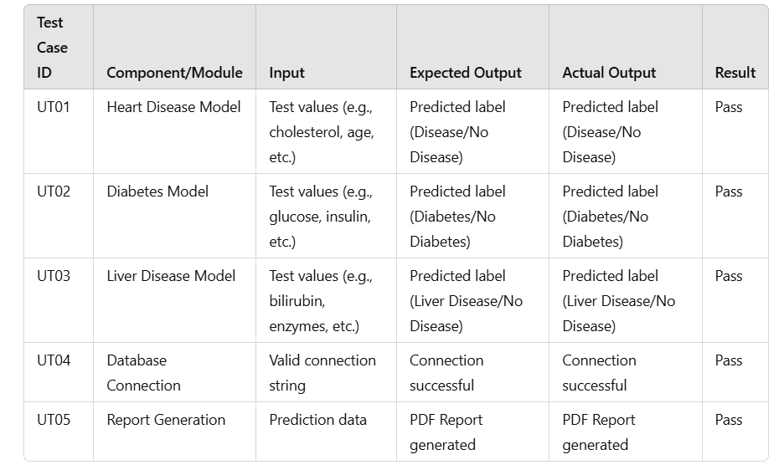
Figure 7 Unit test results

Functional Testing
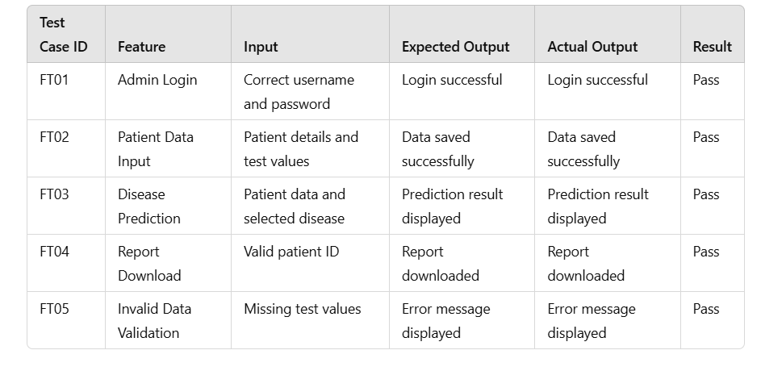
Figure 8 Functional Test results

Integration Testing
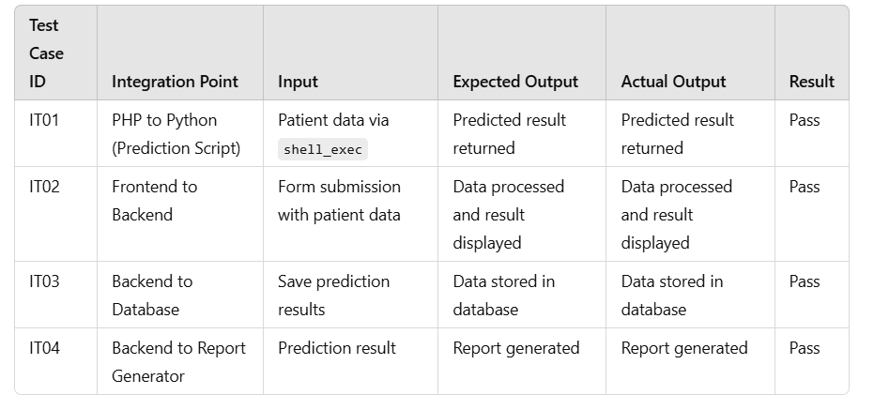
Figure 9 Integration Test results

System Testing
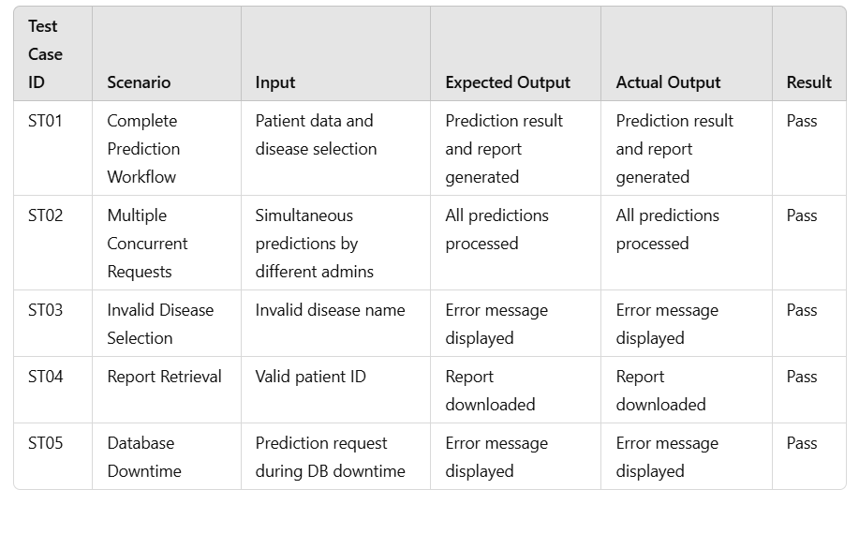
Figure 10 System Test results

Acceptance Testing
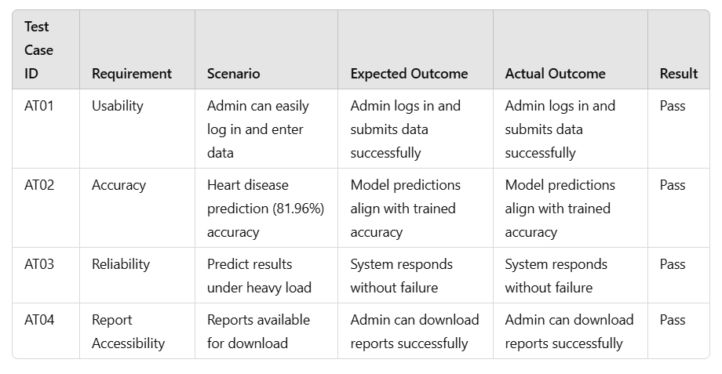
Figure 11 Acceptance Test results

CONCLUSION
The Multi-Disease Prediction System is an advanced and efficient solution for early diagnosis and disease management. By integrating machine learning with intuitive design and report generation, this system empowers healthcare providers and patients to make informed decisions. It serves as a reliable tool for preventive care and enhances the overall healthcare experience.

FUTURE ENHANCEMENTS
Integration of More Diseases:
Add predictors for diseases like cancer, kidney disease, and lung diseases.
Online Deployment:
Host the system on a cloud platform for global accessibility.
Patient Portal:
Allow patients to log in, view their prediction history, and download reports.
Real-Time Notifications:
Notify patients or doctors about high-risk results via email or SMS.
AI-Powered Recommendations:
Offer lifestyle or medical recommendations based on prediction results.

BIBLIOGRAPHY
[1] Priyanka Sonar, Prof. K. JayaMalini,” DIABETES PREDICTION USING DIFFERENT MACHINE LEARNING APPROACHES”, 2019 IEEE,3rd International Conference on Computing Method ologies and Communication (ICCMC)
[2] Archana Singh, Rakesh Kumar, ”Heart Disease Prediction Using Machine Learning Algorithms”, 2020 IEEE, International Confer ence on Electrical and Electronics Engineering (ICE3)
[3] NisharBanu, MA; Gomathy, B.; (2013). Disease Predicting System System Using Data Mining Techniques
[4] Krishnan J, M. ”Prediction of heart disease using machine learning algorithms
[5] PIMA, UCI, KAGGLE for datasets.

APPENDIX – UI

- ADMIN/EXPERT LOGIN

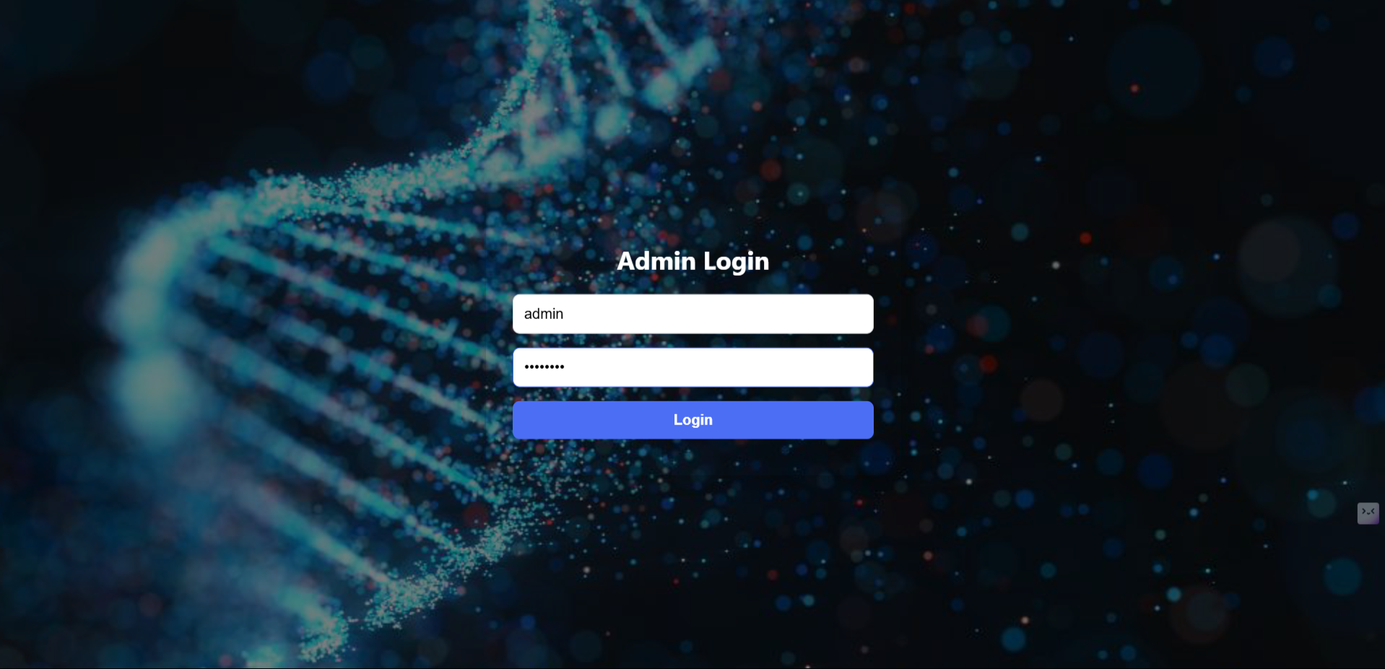
Figure 12 admin.php

- ADMIN/EXPERT DASHBOARD
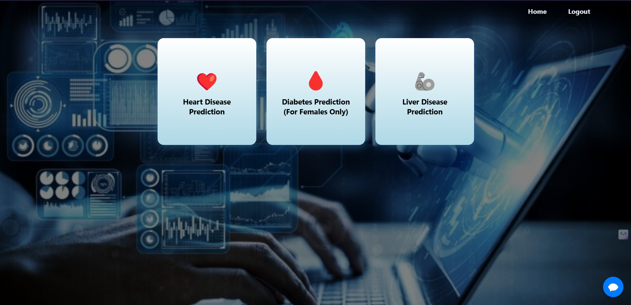
Figure 13 dashboard.php

- PATIENT VERIFICATION

Figure 14 verify_patient.php

- HEART PREDICTION PAGE
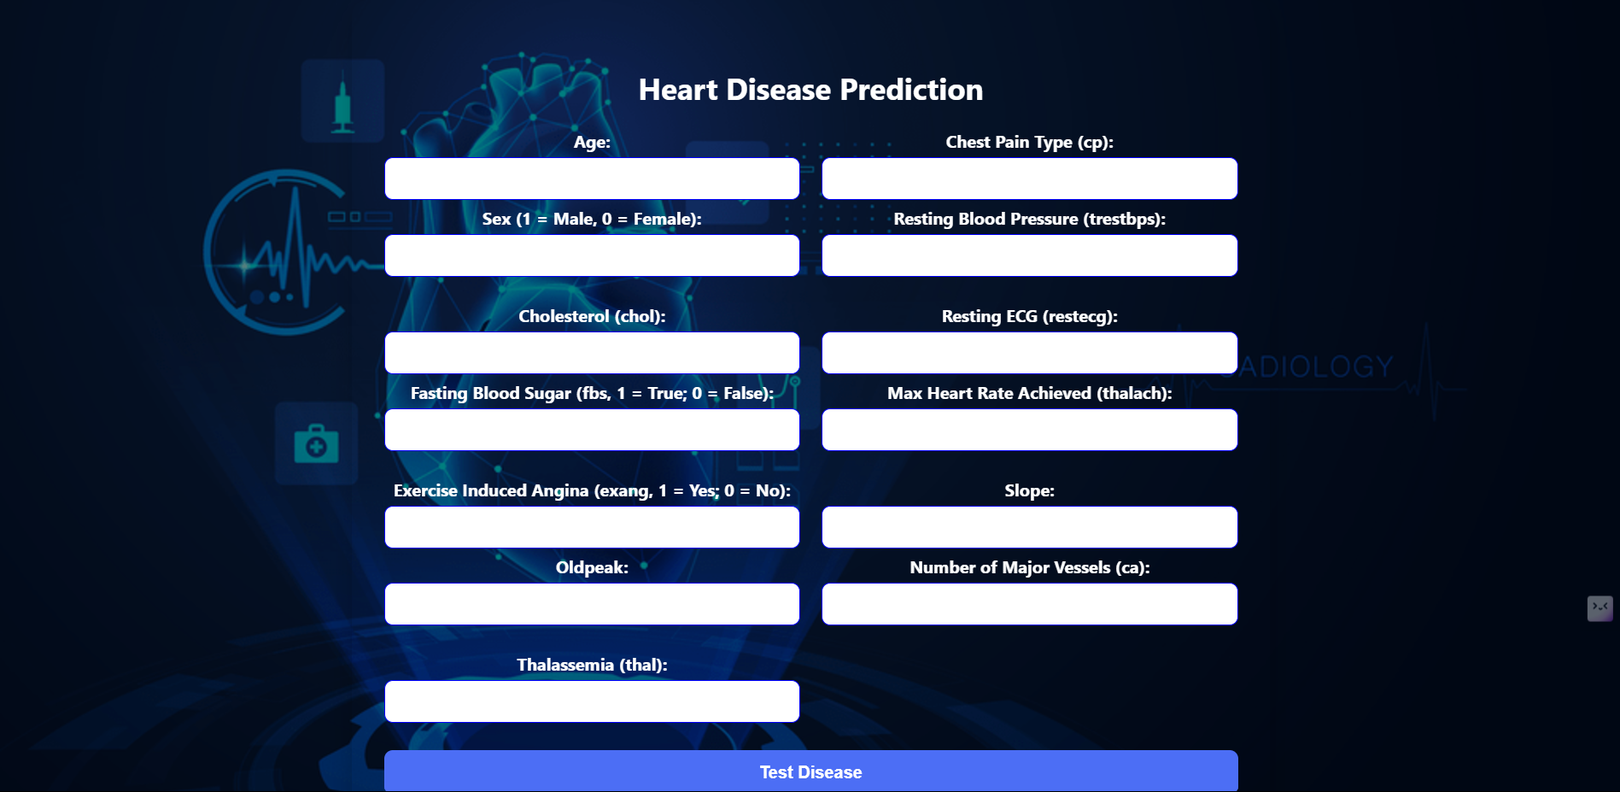
Figure 15 heart.php

- DIABETES PREDICTION PAGE
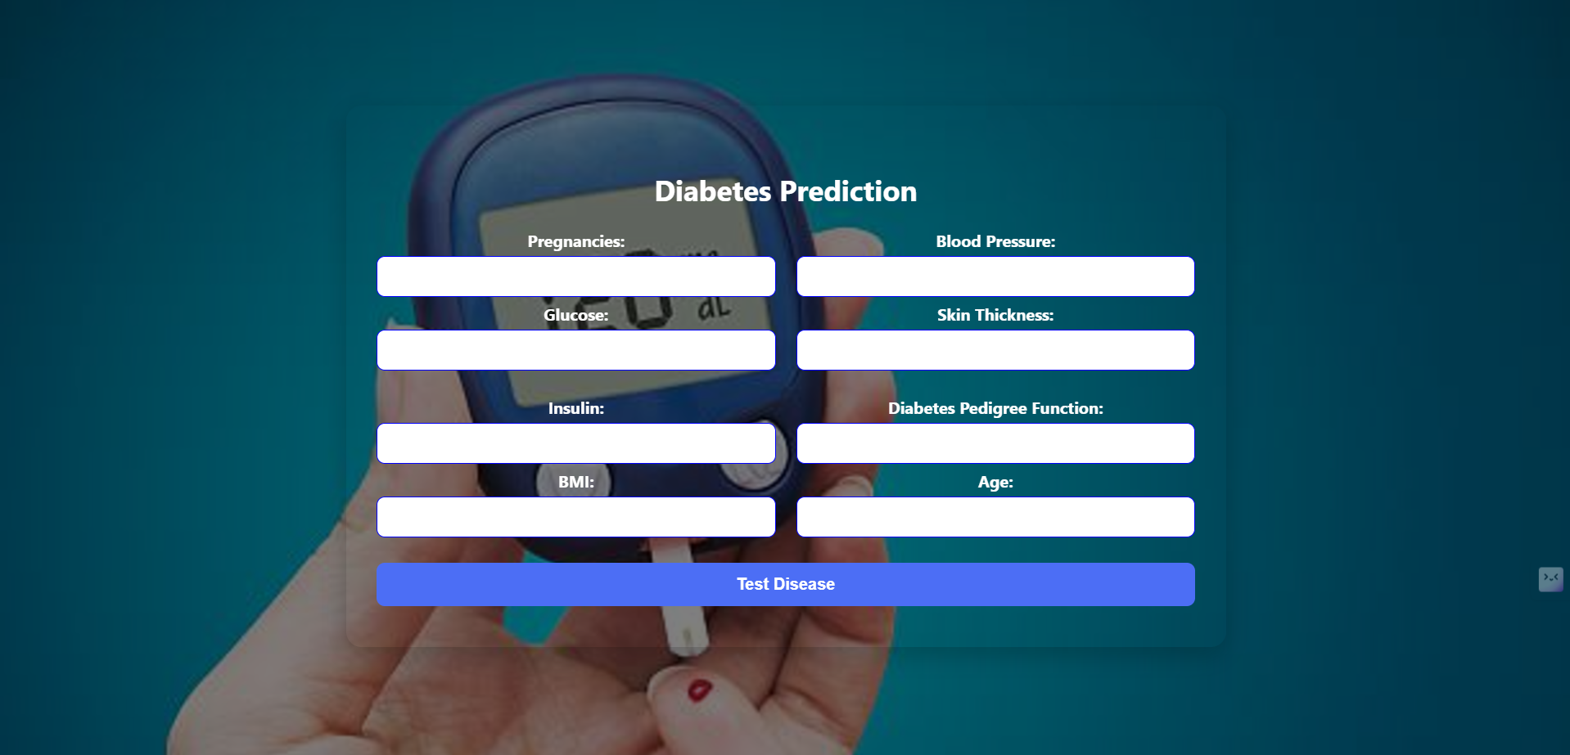
Figure 16 diabetes.php

- LIVER PREDICTION PAGE
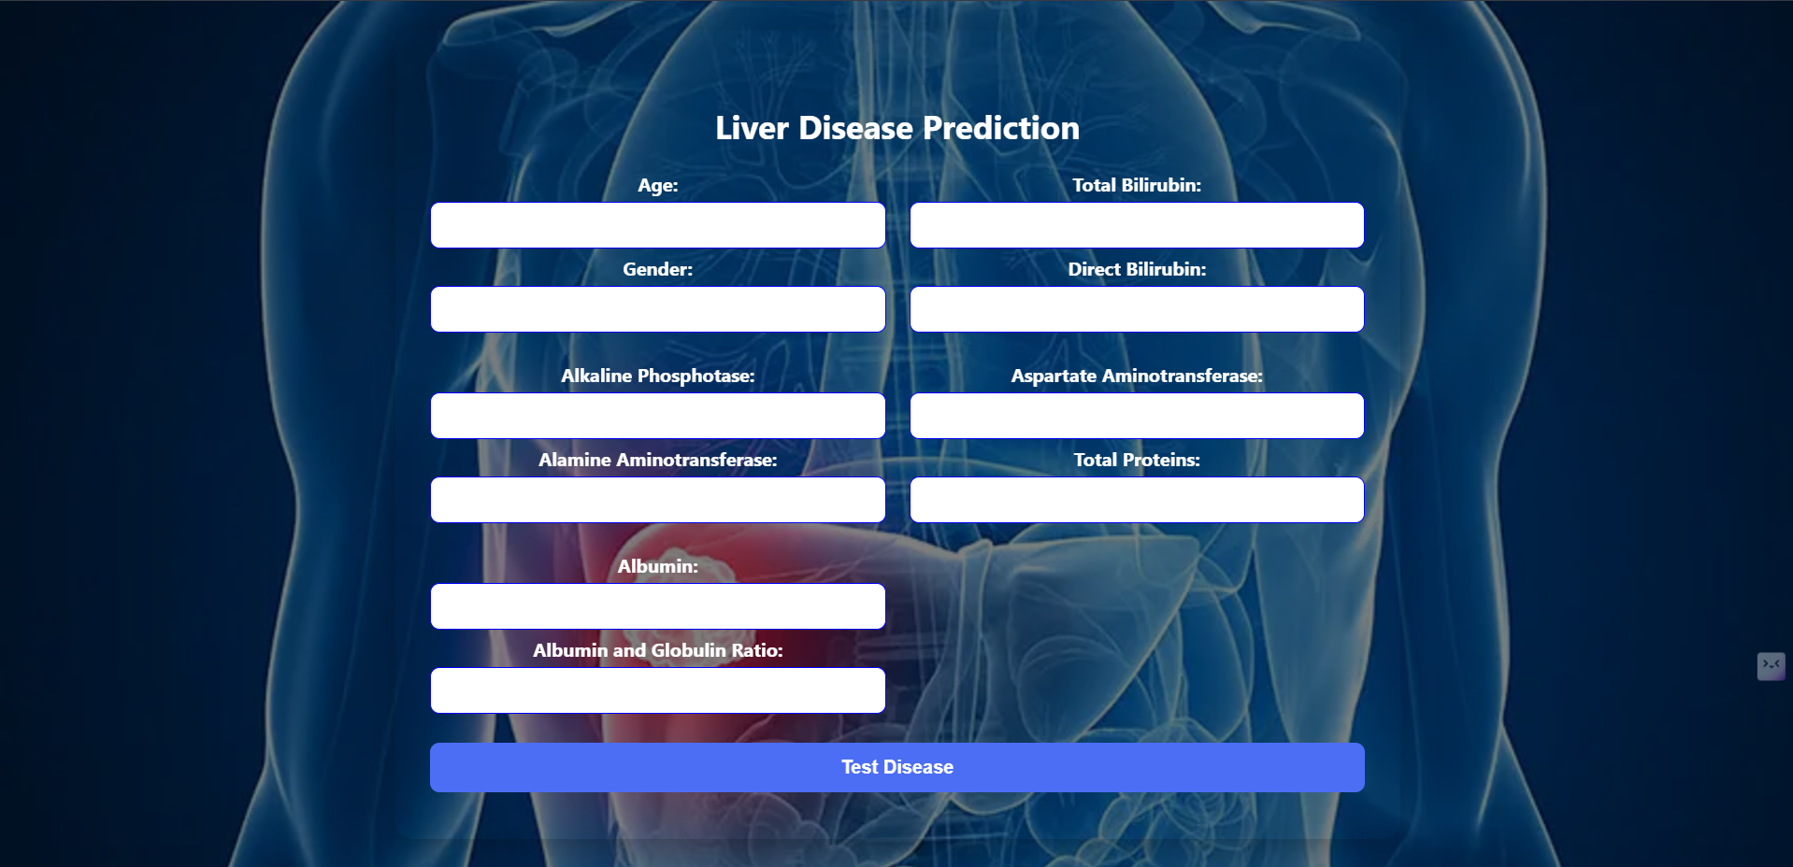
Figure 17 liver.php

- SAMPLE HEART OUTPUT
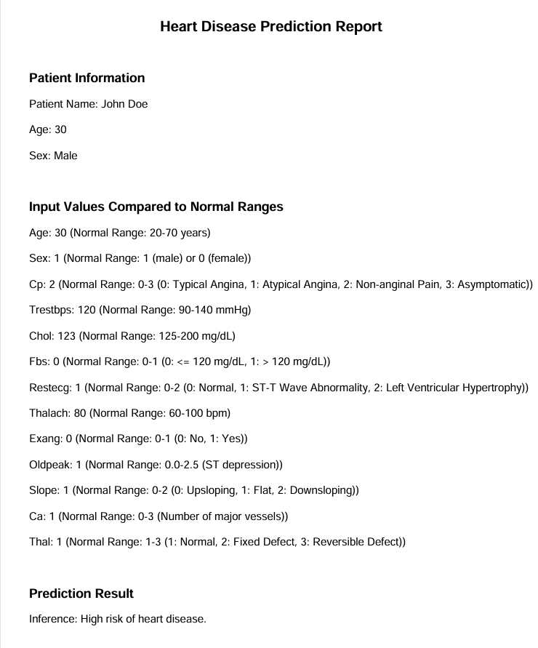
Figure 18 heart disease result

